ASSESSMENT TOOL 1 – High (Coding Challenge)
NAME- G AAMNA KHAN(192371084) COURSE NAME: Programming in Java
CODE – CSA09
1. import java.util.*;

class Book {
private int bookId;
private String title;
private String author;
private double price;
private boolean issued;

public Book(int bookId, String title, String author, double price) {
this.bookId = bookId;
this.title = title;
this.author = author;
this.price = price;
this.issued = false;
}

public int getBookId() { return bookId; }
public String getTitle() { return title; }
public String getAuthor() { return author; }
public double getPrice() { return price; }
public boolean isIssued() { return issued; }

public void setTitle(String title) { this.title = title; }
public void setAuthor(String author) { this.author = author; }
public void setPrice(double price) { this.price = price; }

public boolean issueBook() {
if (issued) {
System.out.println("Book already issued: " + title);
return false;
}
issued = true;
System.out.println("Book issued: " + title);
return true;
}

public boolean returnBook() {
if (!issued) {
System.out.println("Book was not issued: " + title);
return false;
}
issued = false;
System.out.println("Book returned: " + title);
return true;
}

public void display() {
System.out.println("ID: " + bookId + " | Title: " + title + " | Author: " + author
+ " | Price: " + price + " | Issued: " + issued);
}
}

public class LibraryManagement {
static Book[] books = new Book[100];
static int count = 0;

public static void main(String[] args) {
addBook(new Book(1, "Java Basics", "James Gosling", 450.0));
addBook(new Book(2, "Data Structures", "Robert Lafore", 600.0));
addBook(new Book(3, "Clean Code", "Robert Martin", 550.0));

System.out.println("\n--- All Books ---");
displayAll();

System.out.println("\n--- Issue Book ID 1 ---");
issueBook(1);
System.out.println("--- Issue Book ID 1 again (should fail) ---");
issueBook(1);

System.out.println("\n--- Return Book ID 1 ---");
returnBook(1);
System.out.println("--- Return Book ID 2 (not issued, should fail) ---");
returnBook(2);

System.out.println("\n--- Search Book ID 3 ---");
searchBook(3);
System.out.println("--- Search Book ID 99 (not found) ---");
searchBook(99);
}

static void addBook(Book b) {
books[count++] = b;
System.out.println("Added: " + b.getTitle());
}

static void issueBook(int id) {
Book b = findBook(id);
if (b != null) b.issueBook();
else System.out.println("Book not found: " + id);
}

static void returnBook(int id) {
Book b = findBook(id);
if (b != null) b.returnBook();
else System.out.println("Book not found: " + id);
}

static void searchBook(int id) {
Book b = findBook(id);
if (b != null) b.display();
else System.out.println("Book not found: " + id);
}

static Book findBook(int id) {
for (int i = 0; i < count; i++) {
if (books[i].getBookId() == id) return books[i];
}
return null;
}

static void displayAll() {
for (int i = 0; i < count; i++) books[i].display();
}
}
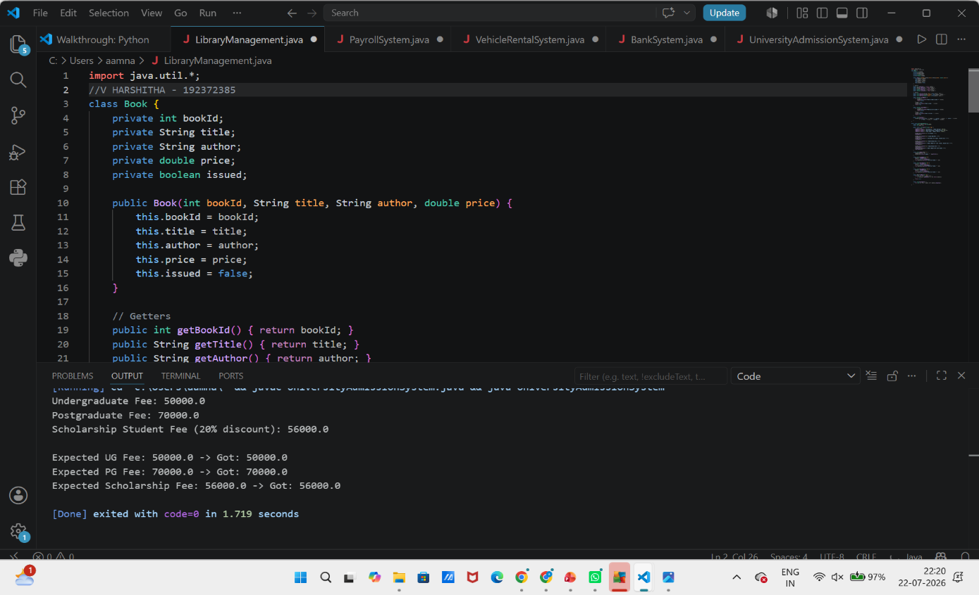
2. abstract class Employee {
protected int empId;
protected String name;

public Employee(int empId, String name) {
this.empId = empId;
this.name = name;
}

public abstract double calculateSalary();

public void displayDetails() {
System.out.println("ID: " + empId + " | Name: " + name
+ " | Salary: " + calculateSalary());
}
}

class PermanentEmployee extends Employee {
private double basicSalary;
private double bonus;

public PermanentEmployee(int empId, String name, double basicSalary, double bonus) {
super(empId, name);
this.basicSalary = basicSalary;
this.bonus = bonus;
}

@Override
public double calculateSalary() {
return basicSalary + bonus;
}
}

class ContractEmployee extends Employee {
private double perDayRate;
private int daysWorked;

public ContractEmployee(int empId, String name, double perDayRate, int daysWorked) {
super(empId, name);
this.perDayRate = perDayRate;
this.daysWorked = daysWorked;
}

@Override
public double calculateSalary() {
return perDayRate * daysWorked;
}
}

public class PayrollSystem {
public static void main(String[] args) {
Employee[] employees = new Employee[3];
employees[0] = new PermanentEmployee(1, "Amit", 40000, 5000);
employees[1] = new ContractEmployee(2, "Sara", 1200, 20);
employees[2] = new PermanentEmployee(3, "Raj", 55000, 0);

System.out.println("--- Employee Payroll ---");
for (Employee e : employees) {
e.displayDetails(); // runtime polymorphism
}

// Test case validations
System.out.println("\nExpected Amit salary: 45000.0 -> Got: " + employees[0].calculateSalary());
System.out.println("Expected Sara salary: 24000.0 -> Got: " + employees[1].calculateSalary());
}
}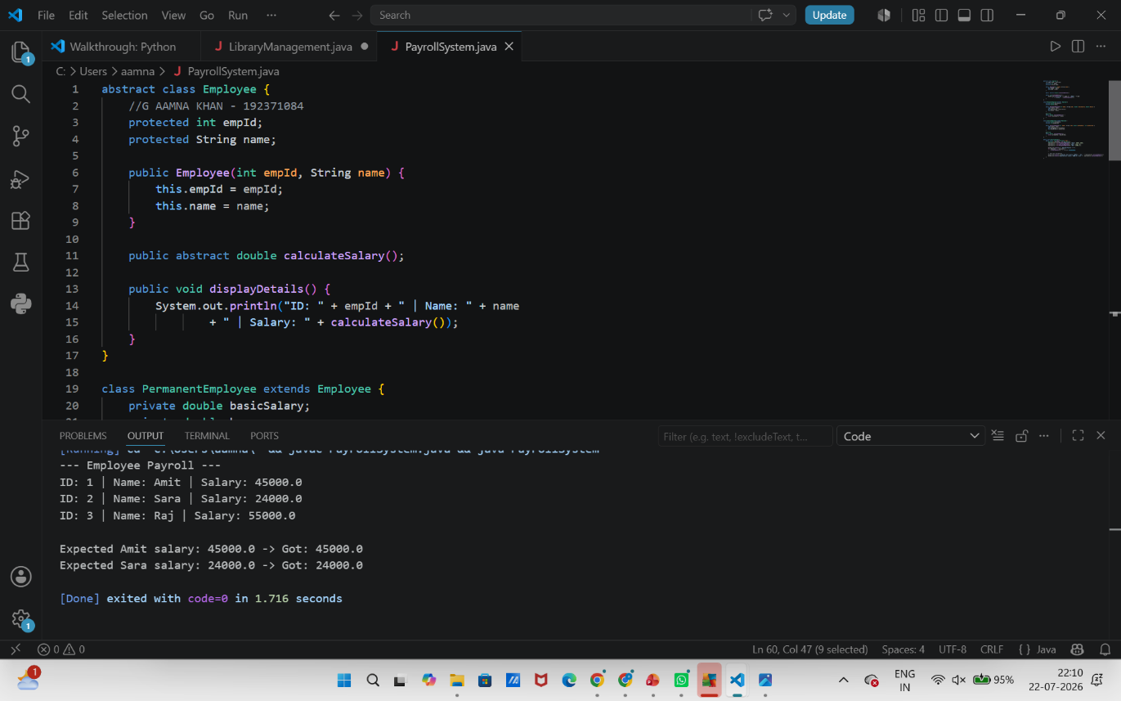

3. abstract class Vehicle {
protected String vehicleNumber;

public Vehicle(String vehicleNumber) {
this.vehicleNumber = vehicleNumber;
}

public abstract double calculateRent(int days);

public void generateBill(int days) {
System.out.println("Vehicle: " + vehicleNumber + " | Days: " + days
+ " | Rent: " + calculateRent(days));
}
}

class Car extends Vehicle {
public Car(String vehicleNumber) { super(vehicleNumber); }
@Override
public double calculateRent(int days) { return days * 1500; }
}

class Bike extends Vehicle {
public Bike(String vehicleNumber) { super(vehicleNumber); }
@Override
public double calculateRent(int days) { return days * 500; }
}

class Bus extends Vehicle {
public Bus(String vehicleNumber) { super(vehicleNumber); }
@Override
public double calculateRent(int days) { return days * 3000; }
}

public class VehicleRentalSystem {
public static void main(String[] args) {
Vehicle[] vehicles = {
new Car("KA-01-1234"),
new Bike("KA-02-5678"),
new Bus("KA-03-9999")
};

int[] rentalDays = {3, 5, 2};

System.out.println("--- Rental Bills ---");
for (int i = 0; i < vehicles.length; i++) {
vehicles[i].generateBill(rentalDays[i]);
}

// Test cases
System.out.println("\nExpected Car rent (3 days): 4500.0 -> Got: " + vehicles[0].calculateRent(3));
System.out.println("Expected Bike rent (5 days): 2500.0 -> Got: " + vehicles[1].calculateRent(5));
System.out.println("Expected Bus rent (2 days): 6000.0 -> Got: " + vehicles[2].calculateRent(2));
}
}
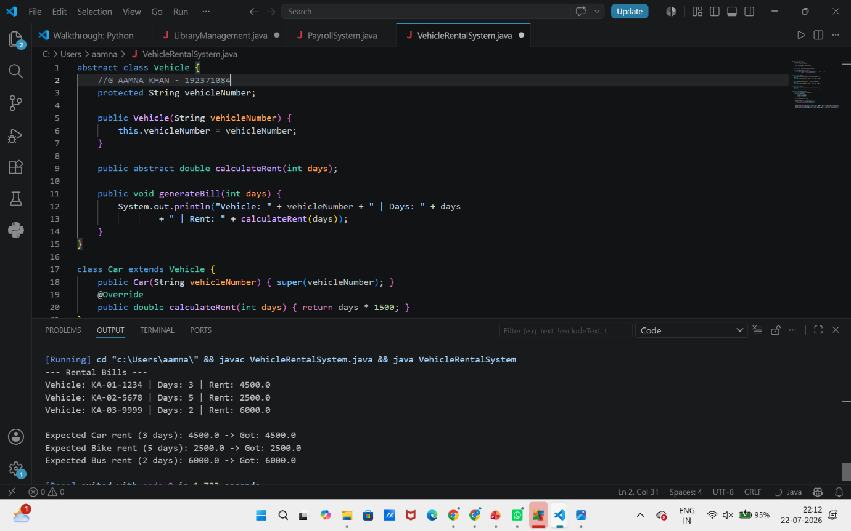
4. class BankAccount {
private String accountNumber;
private String holderName;
private double balance;

public BankAccount(String accountNumber, String holderName, double initialBalance) {
this.accountNumber = accountNumber;
this.holderName = holderName;
this.balance = initialBalance >= 0 ? initialBalance : 0;
}

public String getAccountNumber() { return accountNumber; }
public String getHolderName() { return holderName; }
public double getBalance() { return balance; }

public boolean deposit(double amount) {
if (amount <= 0) {
System.out.println("Invalid deposit amount: " + amount);
return false;
}
balance += amount;
System.out.println("Deposited " + amount + " | New Balance: " + balance);
return true;
}

public boolean withdraw(double amount) {
if (amount <= 0) {
System.out.println("Invalid withdrawal amount: " + amount);
return false;
}
if (amount > balance) {
System.out.println("Insufficient balance. Current balance: " + balance);
return false;
}
balance -= amount;
System.out.println("Withdrew " + amount + " | New Balance: " + balance);
return true;
}

public void inquireBalance() {
System.out.println("Account: " + accountNumber + " | Holder: " + holderName
+ " | Balance: " + balance);
}
}

public class BankSystem {
public static void main(String[] args) {
BankAccount acc = new BankAccount("AC1001", "Amna", 10000);

System.out.println("--- Test Cases ---");
acc.inquireBalance();

System.out.println("\nValid deposit:");
acc.deposit(2000);

System.out.println("\nInvalid deposit (negative):");
acc.deposit(-500);

System.out.println("\nValid withdrawal:");
acc.withdraw(3000);

System.out.println("\nInvalid withdrawal (exceeds balance):");
acc.withdraw(100000);

System.out.println("\nFinal balance check:");
acc.inquireBalance();

// balance cannot be accessed/modified directly - e.g. acc.balance = 999999; would not compile
}
}
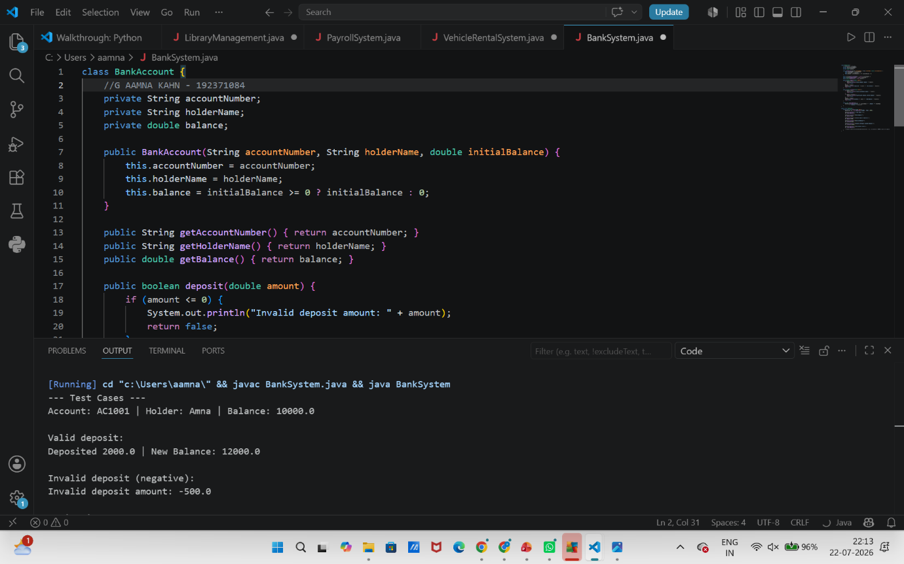
5.
class Admission {
// Undergraduate
public double calculateFee(String type, double baseFee) {
return baseFee;
}

// Postgraduate (with lab fee)
public double calculateFee(String type, double baseFee, double labFee) {
return baseFee + labFee;
}

// Scholarship students (with discount percentage)
public double calculateFee(String type, double baseFee, double labFee, double discountPercent) {
double total = baseFee + labFee;
double discount = total * discountPercent / 100;
return total - discount;
}
}

public class UniversityAdmissionSystem {
public static void main(String[] args) {
Admission admission = new Admission();

double ugFee = admission.calculateFee("UG", 50000);
System.out.println("Undergraduate Fee: " + ugFee);

double pgFee = admission.calculateFee("PG", 60000, 10000);
System.out.println("Postgraduate Fee: " + pgFee);

double scholarshipFee = admission.calculateFee("Scholarship", 60000, 10000, 20);
System.out.println("Scholarship Student Fee (20% discount): " + scholarshipFee);

// Test case validations
System.out.println("\nExpected UG Fee: 50000.0 -> Got: " + ugFee);
System.out.println("Expected PG Fee: 70000.0 -> Got: " + pgFee);
System.out.println("Expected Scholarship Fee: 56000.0 -> Got: " + scholarshipFee);
}
}

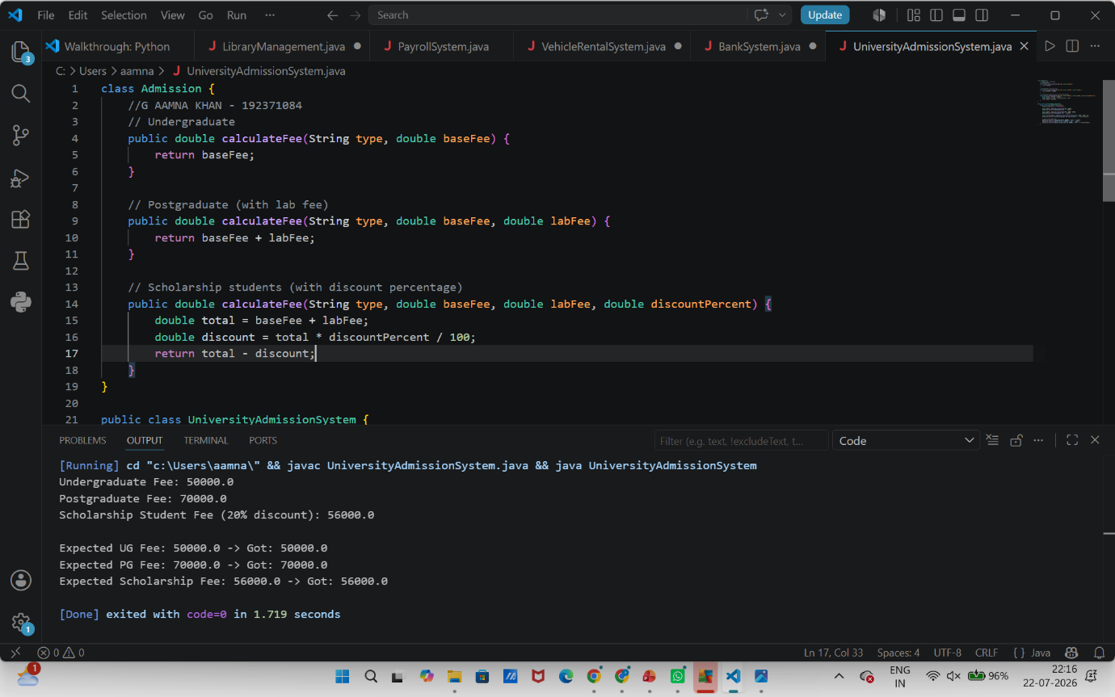
6. Shape Area Calculator using Abstract Class &amp; Polymorphism
import java.util.Scanner;
abstract class Shape {
protected String name;
public Shape(String name) {
this.name = name;
}
public abstract double area();
public void display() {
System.out.printf("%-12s Area = %.2f%n", name, area());
}
}
class Circle extends Shape {
private double radius;
public Circle(double radius) {
super("Circle");
if (radius <= 0) throw new IllegalArgumentException("Radius must be positive");
this.radius = radius;
}

@Override
public double area() {
return Math.PI * radius * radius;
}
}
class Rectangle extends Shape {
private double length, breadth;
public Rectangle(double length, double breadth) {
super("Rectangle");
if (length <= 0 || breadth <= 0) throw new IllegalArgumentException("Dimensions must be positive");
this.length = length;
this.breadth = breadth;
}

@Override
public double area() {
return length * breadth;
}
}
class Triangle extends Shape {
private double base, height;
public Triangle(double base, double height) {
super("Triangle");
if (base <= 0 || height <= 0) throw new IllegalArgumentException("Base/height must be positive");
this.base = base;
this.height = height;
}
@Override
public double area() {
return 0.5 * base * height;
}
}
public class Main {
public static void main(String[] args) {
// Array of Shape references -> polymorphic behavior
Shape[] shapes = new Shape[4];
shapes[0] = new Circle(5);
shapes[1] = new Rectangle(4, 6);
shapes[2] = new Triangle(8, 3);
shapes[3] = new Circle(2.5);
System.out.println("===== Shape Area Report (Polymorphic Dispatch) =====");
double totalArea = 0;
for (Shape s : shapes) {
s.display(); // calls the correct area() at runtime
totalArea += s.area();
}
System.out.printf("Total area of all shapes = %.2f%n", totalArea);
System.out.println("\n===== Test Cases =====");
runTestCases();
}
static void runTestCases() {
int passed = 0, total = 0;
total++;
if (approxEqual(new Circle(1).area(), Math.PI)) { System.out.println("Test 1 PASS: Circle(r=1) area = pi"); passed++; }
else System.out.println("Test 1 FAIL");
total++;
if (approxEqual(new Rectangle(3, 4).area(), 12.0)) { System.out.println("Test 2 PASS: Rectangle(3,4) area = 12"); passed++; }
else System.out.println("Test 2 FAIL");
total++;
if (approxEqual(new Triangle(6, 4).area(), 12.0)) { System.out.println("Test 3 PASS: Triangle(base=6,h=4) area = 12"); passed++; }
else System.out.println("Test 3 FAIL");

total++;
Shape s = new Rectangle(5, 5);
if (approxEqual(s.area(), 25.0)) { System.out.println("Test 4 PASS: Polymorphic call via Shape ref works"); passed++; }
else System.out.println("Test 4 FAIL");
total++;
try {
new Circle(-1);
System.out.println("Test 5 FAIL: negative radius should throw exception");
} catch (IllegalArgumentException e) {
System.out.println("Test 5 PASS: invalid radius correctly rejected");
passed++;
}
System.out.println(passed + "/" + total + " test cases passed.");
}
static boolean approxEqual(double a, double b) {
return Math.abs(a - b) < 1e-6;
}
}
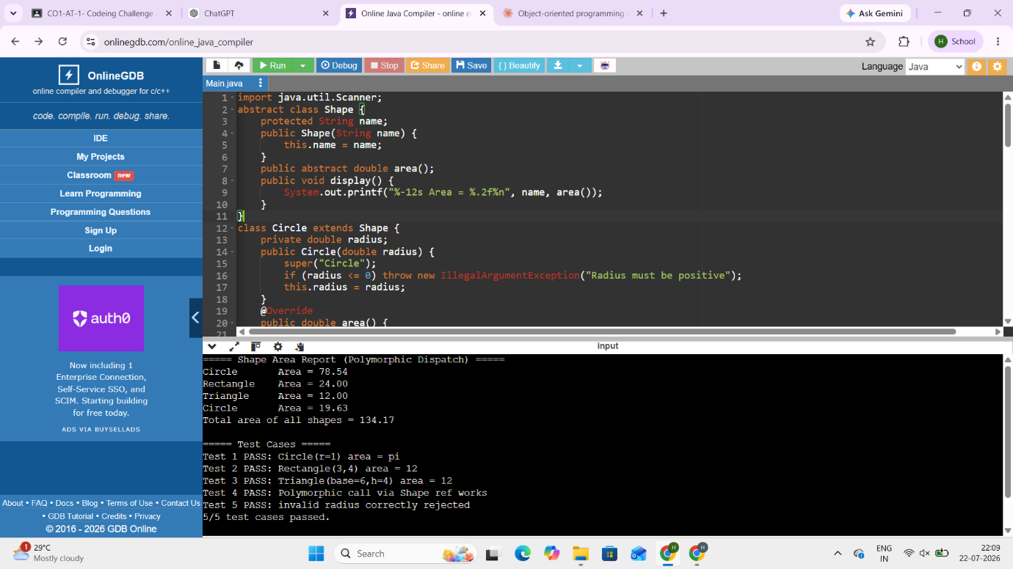
7 Hospital Management System
import java.util.ArrayList;
import java.util.List;
interface MedicalRecord {
void addRecord(String detail);
void displayRecord();
}
class Patient implements MedicalRecord {
private String name;
private int id;
private List<String> history = new ArrayList<>();

public Patient(int id, String name) {
this.id = id;
this.name = name;
}

@Override
public void addRecord(String detail) {
history.add(detail);
}
@Override
public void displayRecord() {
System.out.println("Patient ID: " + id + " | Name: " + name);
if (history.isEmpty()) {
System.out.println(" No medical history recorded.");
} else {
for (String h : history) System.out.println(" - " + h);
}
}

public String getName() { return name; }
public int getId() { return id; }
public int getHistorySize() { return history.size(); }
}
class Doctor implements MedicalRecord {
private String name;
private String specialization;
private List<String> consultations = new ArrayList<>();
public Doctor(String name, String specialization) {
this.name = name;
this.specialization = specialization;
}
@Override
public void addRecord(String detail) {
consultations.add(detail);
}
@Override
public void displayRecord() {
System.out.println("Dr. " + name + " (" + specialization + ")");
if (consultations.isEmpty()) {
System.out.println(" No consultations recorded.");
} else {
for (String c : consultations) System.out.println(" - " + c);
}
}
public void examine(Patient p, String diagnosis) {
p.addRecord("Diagnosed by Dr. " + name + ": " + diagnosis);
this.addRecord("Examined " + p.getName() + " (ID " + p.getId() + "): " + diagnosis);
}

public String getName() { return name; }
}
public class Main {
public static void main(String[] args) {
Patient p1 = new Patient(101, "Ravi");
Doctor d1 = new Doctor("Meena", "Cardiology");
MedicalRecord[] records = { p1, p2, d1 };
System.out.println("===== Before any consultation =====");
for (MedicalRecord r : records) r.displayRecord();
d1.examine(p1, "Mild arrhythmia, prescribed beta blockers");
d1.examine(p2, "Routine checkup, all normal");
p1.addRecord("Follow-up scheduled in 2 weeks");
System.out.println("\n===== After consultations =====");
for (MedicalRecord r : records) r.displayRecord();
System.out.println("\n===== Test Cases =====");
runTestCases();
}
static void runTestCases() {
int passed = 0, total = 0;
total++;
Patient tp = new Patient(1, "Test Patient");
tp.addRecord("Fever recorded");
if (tp.getHistorySize() == 1) { System.out.println("Test 1 PASS: addRecord adds one entry"); passed++; }
else System.out.println("Test 1 FAIL");
total++;
Doctor td = new Doctor("Test Doc", "General");
td.examine(tp, "Viral fever");
if (tp.getHistorySize() == 2) { System.out.println("Test 2 PASS: examine() updates patient record"); passed++; }
else System.out.println("Test 2 FAIL");
total++;
MedicalRecord ref = tp;
try {
ref.displayRecord();
System.out.println("Test 3 PASS: displayRecord() callable via interface reference");
passed++;
} catch (Exception e) {
System.out.println("Test 3 FAIL");
}

System.out.println(passed + "/" + total + " test cases passed.");
}
}
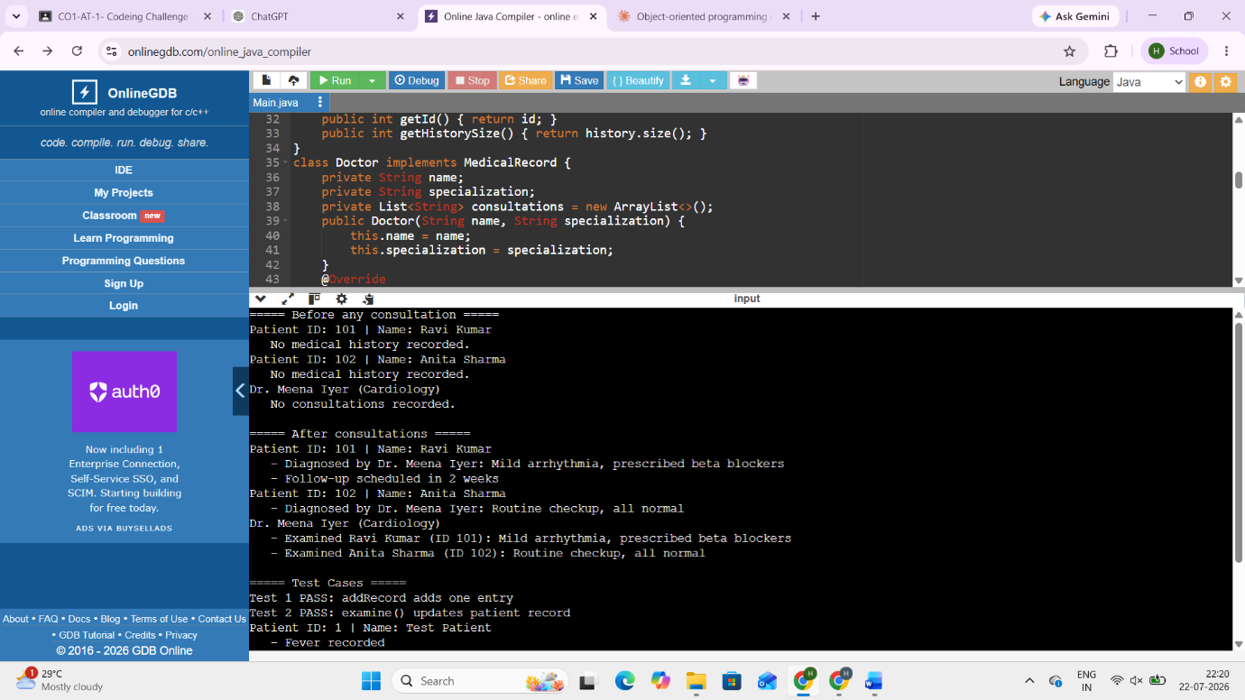
8. Online Shopping Order System using Packages
class Product {
int id;
String name;
double price;
Product(int id, String name, double price) {
this.id = id;
this.name = name;
this.price = price;
}
}
class Order {
Product product;
int quantity;
Order(Product product, int quantity) {
this.product = product;
this.quantity = quantity;
}
double calculateTotal() {
return product.price * quantity;
}
void displayBill() {
System.out.println("===== ORDER BILL =====");
System.out.println("Product ID : " + product.id);
System.out.println("Product Name : " + product.name);
System.out.println("Price : ₹" + product.price);
System.out.println("Quantity : " + quantity);
System.out.println("---------------------------");
System.out.println("Total Amount : ₹" + calculateTotal());
}
}
public class Main {
public static void main(String[] args) {
Product p1 = new Product(101, "Laptop", 50000);
Product p2 = new Product(102, "Mouse", 800);
Order order1 = new Order(p1, 2);
Order order2 = new Order(p2, 3);
order1.displayBill();
System.out.println();
order2.displayBill();
}
}
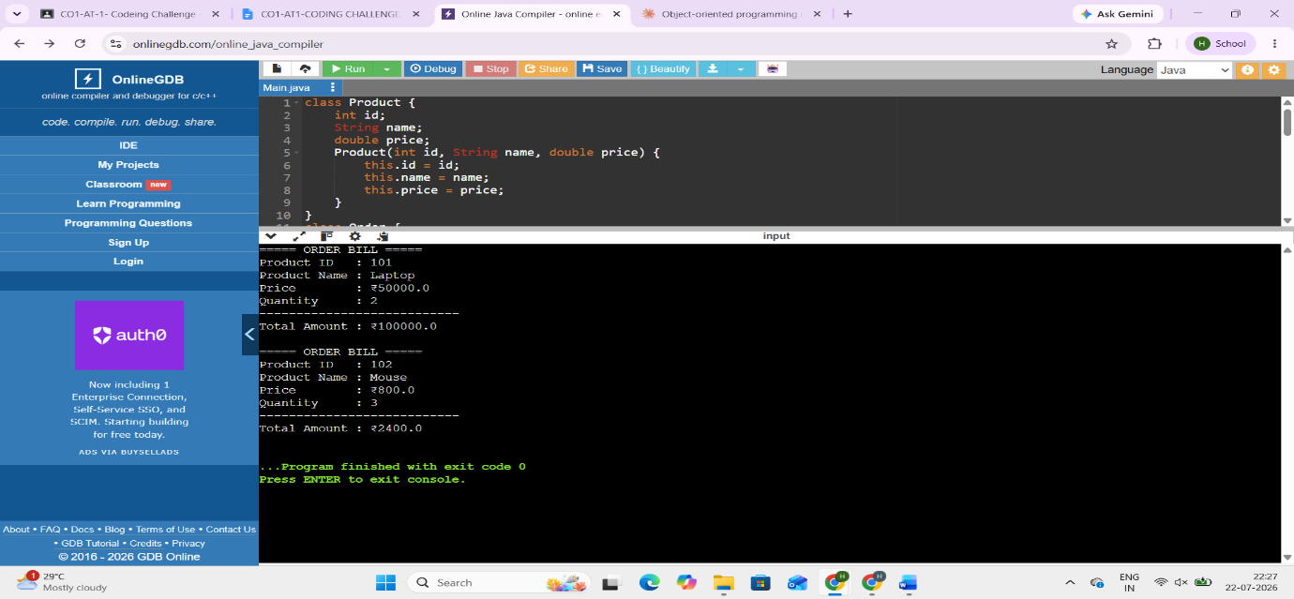
9. Student Result Analyzer using Arrays of Objects
import java.util.Scanner;
class Student {
int roll;
String name;
int m1, m2, m3;
Student(int roll, String name, int m1, int m2, int m3) {
this.roll = roll;
this.name = name;
this.m1 = m1;
this.m2 = m2;
this.m3 = m3;
}
int total() {
return m1 + m2 + m3;
}
double average() {
return total() / 3.0;
}
String grade() {
double avg = average();
if (avg >= 90)
return "A+";
else if (avg >= 75)
return "A";
else if (avg >= 60)
return "B";
else if (avg >= 50)
return "C";
else
return "Fail";
}
}
public class Main {
public static void main(String args[]) {
Scanner sc = new Scanner(System.in);
System.out.print("Enter number of students: ");
int n = sc.nextInt();
Student students[] = new Student[n];
for (int i = 0; i < n; i++) {
System.out.println("\nStudent " + (i + 1));
System.out.print("Roll No: ");
int roll = sc.nextInt();
sc.nextLine();
System.out.print("Name: ");
String name = sc.nextLine();
System.out.print("Marks1: ");
int m1 = sc.nextInt();
System.out.print("Marks2: ");
int m2 = sc.nextInt();
System.out.print("Marks3: ");
int m3 = sc.nextInt();
students[i] = new Student(roll, name, m1, m2, m3);
}
int highest = students[0].total();
Student topper = students[0];
System.out.println("\nRESULT");
for (Student s : students) {
System.out.println("--------------------------");
System.out.println("Roll : " + s.roll);
System.out.println("Name : " + s.name);
System.out.println("Total : " + s.total());
System.out.println("Average : " + s.average());
System.out.println("Grade : " + s.grade());
if (s.total() > highest) {
highest = s.total();
topper = s;
}
}
System.out.println("\nClass Topper");
System.out.println("Name : " + topper.name);
System.out.println("Total : " + topper.total());

}
}
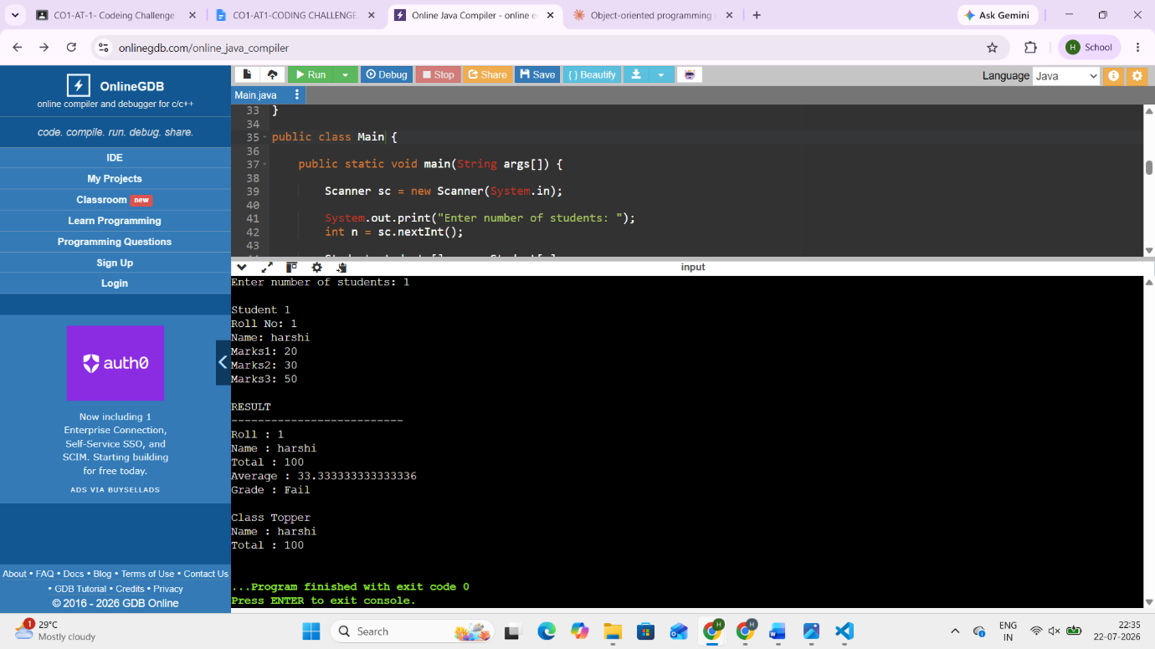
10. Smart Home Device Controller using Hierarchical Inheritance
class Device {
void turnOn() {
System.out.println("Device ON");
}
void turnOff() {
System.out.println("Device OFF");
}
void powerConsumption() {
System.out.println("Power Consumption");
}
}
class Light extends Device {
void powerConsumption() {
System.out.println("Light : 15 Watts");
}
}
class Fan extends Device {
void powerConsumption() {
System.out.println("Fan : 75 Watts");
}
}
class AirConditioner extends Device {
void powerConsumption() {
System.out.println("Air Conditioner : 1500 Watts");
}
}
public class Main {
public static void main(String args[]) {
Device d;
d = new Light();
d.turnOn();
d.powerConsumption();
d.turnOff();
System.out.println();
d = new Fan();
d.turnOn();
d.powerConsumption();
d.turnOff();
System.out.println();
d = new AirConditioner();
d.turnOn();
d.powerConsumption();
d.turnOff();
}
}
